31. Stacked Bar Plot with Error Bars

import matplotlib.pyplot as plt
import numpy as np
groups = ['A', 'B', 'C', 'D']
boys = np.array([20, 35, 30, 35])
girls = np.array([25, 32, 34, 20])
boys_error = [2, 3, 2, 3]
girls_error = [3, 2, 3, 2]
plt.bar(groups, boys, yerr=boys_error, label='Boys')
plt.bar(groups, girls, bottom=boys, yerr=girls_error, label='Girls')
plt.xlabel('Groups')
plt.ylabel('Scores')
plt.title('Stacked Bar Plot with Error Bars')
plt.legend()
plt.show()
OUTPUT:
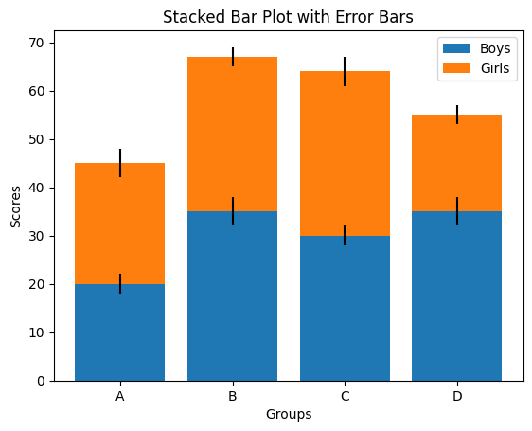

32. Scatter Graph Using Random Distribution
import matplotlib.pyplot as plt
import numpy as np
x = np.random.rand(50)
y = np.random.rand(50)
plt.scatter(x, y)
plt.xlabel('X')
plt.ylabel('Y')
plt.title('Scatter Plot with Random Distribution')
plt.show()
OUTPUT:
